**Submission form**

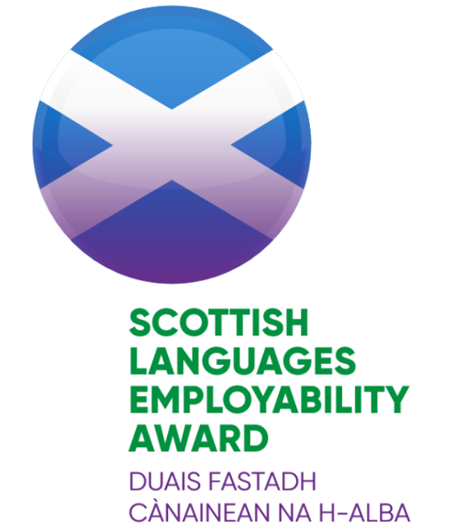

| 1. Information |  | | | | | |
| --- | --- | --- | --- | --- | --- | --- |
| **Name of school** |  | | | | | |
| **School address and postcode** |  | | | | | |
| **Local authority** |  | | | | | |
| **Contact name and position in school** |  | | | | | |
| **Contact e-mail and telephone number** |  | | | | | |
| **School roll** |  | |  | | |  |
| **Year group(s) involved in project** |  | **Are any of the classes involved composite?**  (see FAQs of handbook) | | | | Yes No |
| **Project title** |  | | | | | |
| **Languages incorporated** |  | | | | | |
| **Date started** |  | | | **Date completed (if appropriate)** |  | |
| *Please note that all projects within a submission should take place within the same academic year (see section 3 of handbook)* | | | | | | |
| **Has the school previously participated in the SCILT Scottish Languages Employability Award?** | Yes No | | | **If yes, please give dates, name of project and level of Award.** |  | |
| **Partner organisation(s)** |  | | | | | |
| **Contact(s) at partner organisation(s)** |  | | | | | |

|  |  |
| --- | --- |
| 1. **Project Report** |  |
| 1. **Briefly give an overview of your project and activities. (approx. 300 words)**   **Please include the following:**   * **description of partner(s) involved** * **planning processes** * **activities undertaken** * **feedback** * **impact** * **future plans**   **The Checklist for Award (see Appendix B), although not mandatory, will be useful for recording this information throughout the project and in completing this report.** |  |
| 1. **Evidence** | **Please submit evidence via** [**the online form**](https://hass.eu.qualtrics.com/jfe/form/SV_4GCuasVz3EqWFeu)**.**  **This should be a maximum of 6 pictures (photos/screenshots etc) – see section 5 of the handbook.** |

|  |  |  |  |
| --- | --- | --- | --- |
| **Permissions** | Please indicate if you are happy for your activities to be used as exemplification by SCILT and if all relevant permissions have been obtained according to your school policies. **Yes No** |  | |
| **Signed by School** | **Name** | **Date** |
| **Signed by Partner Organisation** | **Name** | **Date** |
| **Signed off by SCILT/CISS** | **Name** | **Date** |

|  |  |  |  |  |  |
| --- | --- | --- | --- | --- | --- |
| **For SCILT/CISS use only** | | | | | |
| **Comments and Feedback:** | | | | | |
|  | | | | | |
| **Level of Scottish Languages Employability Award awarded and date of award:** | | | | | |
| **Bronze** |  | **Silver** |  | **Gold** |  |

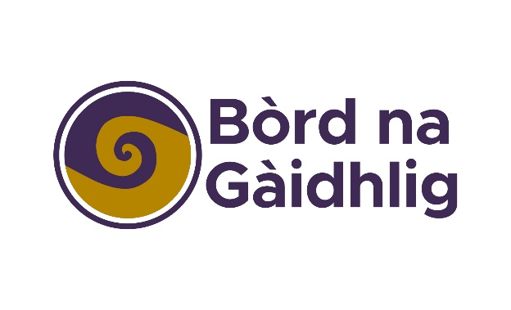

*Bha Duais Fastadh Cànainean na h-Alba air a leasachadh agus ga toirt gu buil le taic-airgid o Bhòrd na Gàidhlig agus GLIF (Gaelic Language Act Implementation Funding).*

*The Scottish Languages Employability Award was developed and implemented with support from Bòrd na Gàidhlig and the Gaelic Language Act Implementation Fund.*